Ofentse oliphant
ST10516061
Web Development
WEDE5020POE

Table of Contents
Organization Overview 1
Website Goals & Objectives and Current Website Analysis 1
References 2

Organization Overview
Landscaper Designer
Landscaping by William Brown
Landscaping by William Brown is landscaping and gardening business based in Bloemfontein CBD, Bloemfontein, Waverley Rd, 9301. William Brown business is open on the weekdays from Monday to Friday, 8am to 5pm, hours vary on public holidays, you must call ahead to confirm. I can’t recall if you do the services alone or have a team with you. I believe your target audience is property owners. On the Destinali website it doesn’t clearly state your services directly, but landscaping and gardening pictures are given.
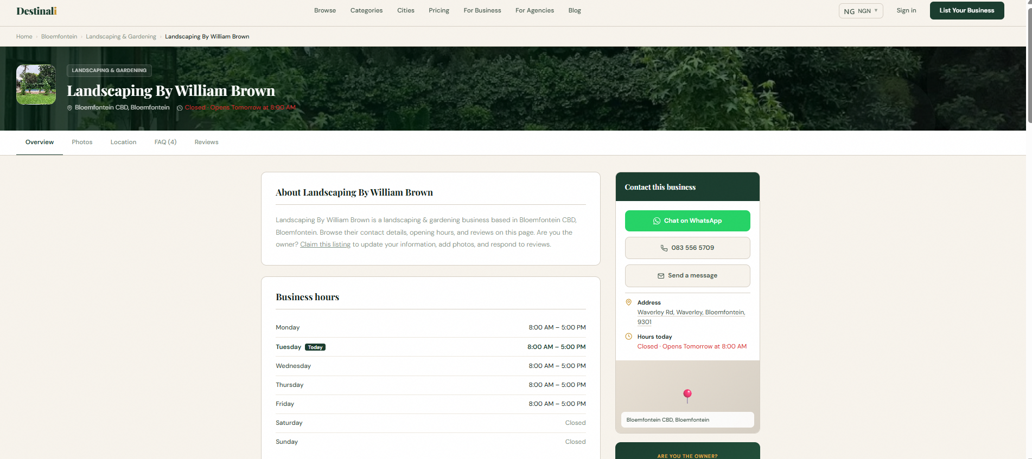

Website Goals & Objectives and Current Website Analysis
My aim with your business is to showcase your business details and what it is about firsthand, to gain attraction from potential clients. To provide an evaluation on site of the client’s garden or area, asking questions such as; does your garden reflect your personality? Is the interior of your office or home in balance with your garden? Discussing the vision, as well as the clients budget. After a thorough evaluation is done, the initial design process will start which is your part. In today’s society everything that has modern technology behind it, succeeds organically. Businesses will be able to be recognized by the world, which can attract potential investors too.

So, I noticed that your website is under Destinali.com, which is also hackable if someone gets access to your personal details. It doesn’t state a clear brief history about your business. I can create or come up with a website for you and a name for your business such as Brownstone Landscapes or BrownScapes. The slogan can be “BRINGING THE BEST GARDEN TO YOUR DORRSTEP!”. Your current website doesn’t state your services fully too. I can design one for you, we can discuss the design aesthetic and branding about it. And the best part about it is that it will be your own website. I will be adding:
- Homepage
- about us
- Enquiry page
- contact page
- services page.
This website will elevate your company, and it will attract more property owners. By implementing modern technology, we help businesses optimize workflows, reduce costs, and drive innovation. Our approach provides businesses with scalable, adaptable solutions that align with market demands and ensure long-term sustainability in the landscaping and gardening industry. If you do approve of this, I can complete the website in a week.

The budget will differ on the domain registration and web hosting. I recommend .co.za domain which will range from R49 to R99 per year for starters then will range R50 to R150 per month.

References
- Landscaping By William Brown (2026) Landscaping By William Brown. Available at: https://destinali.com/bloemfontein/landscaping-gardening/landscaping-by-william-brown-bloemfontein (Accessed: 17 August 2026).
- W3Schools (2026) Learn to Code. Available at: https://www.w3schools.com/ (Accessed: 17 August 2026).

